Development of plug-ins for SpinStudioJ

Environment Configuration
- Installation of Java environment.
- Visit the following URL to download the JDK1.8 installation file . At present, we use JDK1.8 for SpinStudioJ development.
https://www.oracle.com/technetwork/java/javase/downloads/jdk8-downloads-2133151.html.
- Double click on the installation file to install JDK1.8.
- After installation, configure the following three environment variables:
----JAVA_HOME：JDK installation paths.There are folders named “lib”, “bin”, “jre” in this directory. For example：
D:\Java\jdk1.8
----CLASSPATH：class loading paths. For example:
.;%JAVA_HOME%\lib\dt.jar;%JAVA_HOME%\lib\tools.jar;
----PATH: java command execution paths. For example：
%JAVA_HOME%\bin;%JAVA_HOME%\jre\bin;

- Download Eclipse .
Visit the following URL to download Eclipse for RCP and RAP Developers. At present, we use Eclipse Mars(4.5) for SpinStudioJ development.
https://www.eclipse.org/downloads/packages/release/mars/2/eclipse-rcp-and-rap-developers

develop plug-ins
- Create a plug-in project .
From the menu bar, select File > New > Plug-in Project.
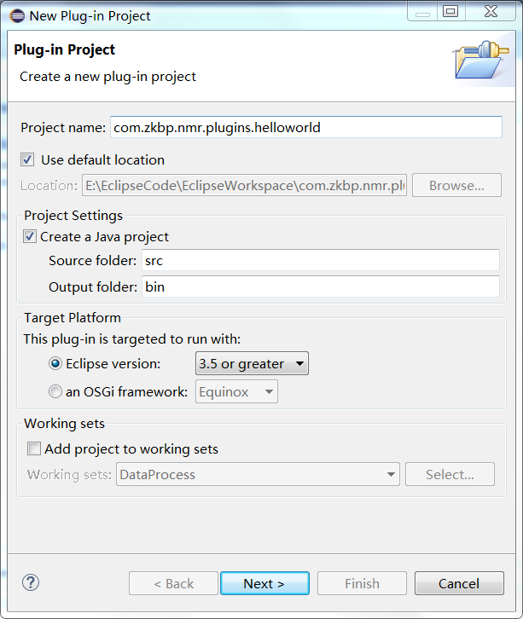
In the Project name field, type your name as the name of your new project, for example "com.zkbp.nmr.plugins.helloworld".
In the Location field, you can use default location or click button “Browse” to select a location in the file system .

- Create a feature project.
From the menu bar, select File > New > Feature Project.
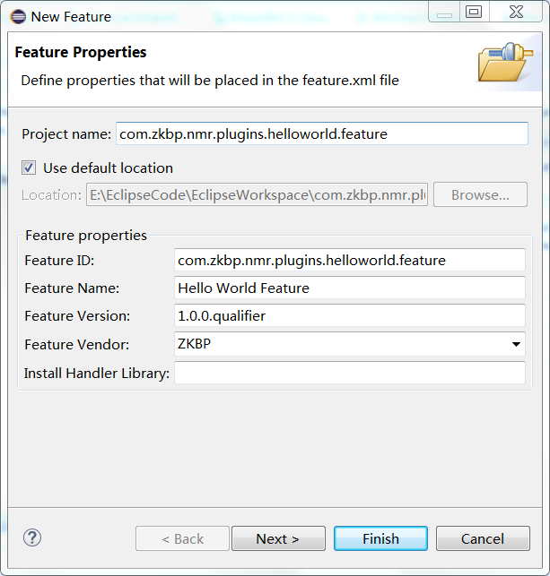
In the Project name field, type your name as the name of your new project, for example "com.zkbp.nmr.plugins.helloworld.feature".
In the Location field, you can use default location or click button “Browse” to select a location in the file system .
In the Feature name field, type your name as the name of your new feature ,for example “Hello World Feature”.
Click button “Finish” when you are done.

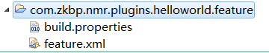
Then a feature project can be seen in the navigator explorer. Double click on the resource “feature.xml” to open an editor.
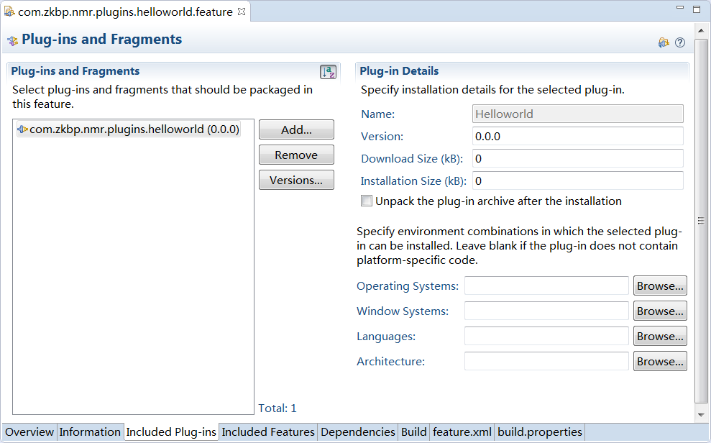
Switch to “Included Plug-ins” page. Click button “Add to” add plug-ins which you want to pack up.Save the contents of this editor.

- Create a Update Site Project.
On the main menu bar, click File > New Project. The New Project wizard opens.
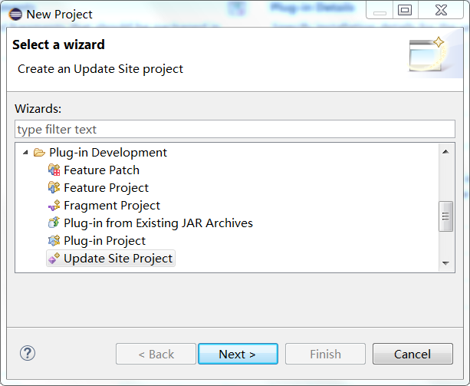
Select Update Site Project ,click button “Next” .New Update Site dialog opens.
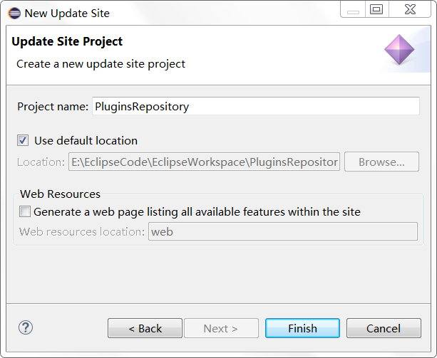
In the Project name field, type your name as the name of your new project, for example "PluginsRepository".
In the Location field, you can use default location or click button “Browse” to select a location in the file system .
Click Finish when you are done.
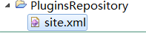
Then a Update Site Project can be seen in the navigator explorer. Double click on the resource “site.xml” to open an editor.
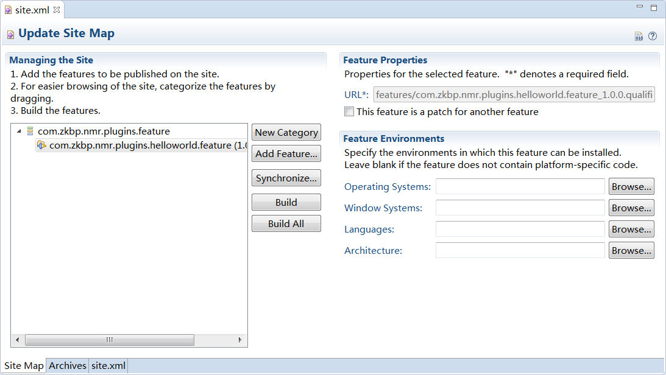
Click button “New Category” to create a new category, then edit the ID and Name of this category. Click button “Add Feature...” to add the feature which you want to pack up.Save the contents of this editor.

- Build the features.
On Site Map page ,click button “Build” to build the selected features or click button “Build All” to build all features.
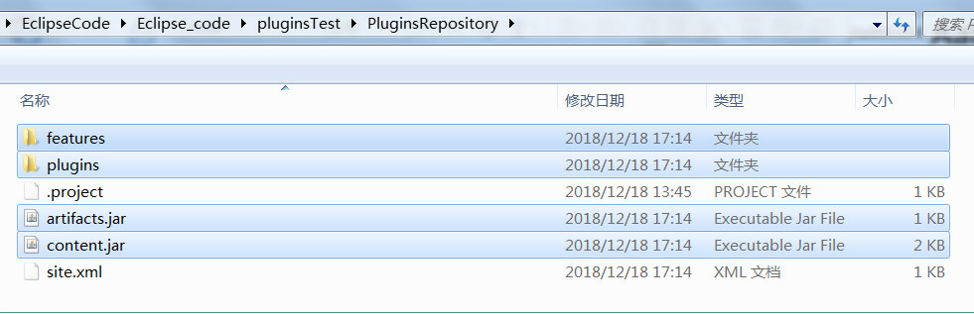
After building,open the directory of the file site.xml. Two folders and two files are created in this directory : features,plugins,artifacts.jar and content.jar.

